It’s a rainy day - song
Let’s go outside, look at the sky
The sky is grey, it’s a rainy day, it’s a rainy day

Let’s go outside, look at the sky
The sky is grey, it’s a windy day, it’s a windy day

Let’s go outside, look at the sky
The sky is grey, it’s a cloudy day, it’s a cloudy day

Let’s go outside, look at the sky
The sky is grey, it’s a foggy day, it’s a foggy day

Words:
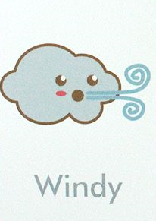
rainy, windy, cloudy, foggy
